Empowering Mental Health: A Chatbot Approach

A Case study Report submitted in partial fulfilment of the requirement for awarding marks as part of the Course Continuous Evaluation

Submitted by

N.CH. SAI MEGHANA - 2023000914

(M.Tech Data Science)

Under the supervision of

R. SIREESHA

DEPARTMENT OF COMPUTER SCIENCE & ENGINEERING GITAM

(Deemed to be University)

VISHAKAPATANAM

March 2024

DEPARTMENT OF COMPUTER SCIENCE AND ENGINEERING

GITAM SCHOOL OF TECHNOLOGY

GITAM (Deemed to be University)

**Introduction:**

In contemporary society, the significance of comprehending mental health cannot be overstated as it profoundly impacts our holistic well-being. Nonetheless, accessing the necessary support can be an arduous task. Various obstacles hinder this process, including the pervasive stigma attached to mental health concerns and the insufficient availability of mental health professionals. Nevertheless, advancements in technology have opened up novel avenues for assistance. Among these innovations, chatbots powered by sophisticated deep learning algorithms stand out as promising tools in the realm of mental health support. The core objective of this endeavor is to leverage the capabilities of deep learning technology to develop a chatbot specifically tailored to address mental health issues. By harnessing the potential of this technology, the aim is to democratize access to mental health assistance, ensuring that it is both readily available and customized to meet the unique needs of every individual.

**Proposed System:**

Our strategy entails the construction of a chatbot employing an advanced deep learning sequential model. This model will undergo comprehensive training utilizing a diverse array of conversational data, encompassing various scenarios and responses pertinent to mental health concerns. Through this training process, the chatbot will acquire the capability to engage with users in a manner akin to natural conversation, offering personalized support, guidance, and access to relevant resources tailored to the individual requirements of each user. Leveraging sophisticated natural language processing techniques, the chatbot will adeptly comprehend user queries and generate responses imbued with a human-like quality. This approach aims to cultivate an environment of empathy and support, fostering a conducive space for users seeking assistance with their mental health challenges.

**Problem Statement:**

The prevalence of mental health challenges is on the rise globally, yet a significant portion of individuals still face obstacles in accessing the necessary support. Many refrain from seeking assistance due to the pervasive stigma surrounding mental health issues or due to limited access to resources. Additionally, the insufficient number of mental health professionals exacerbates the situation, resulting in prolonged waiting periods for appointments. In response to these challenges, this project endeavors to utilize deep learning technology to develop a chatbot capable of delivering instantaneous and confidential support. By leveraging this innovative approach, we aim to mitigate the gap between individuals in need of assistance and the available resources, thereby fostering a more accessible avenue for mental health support.

**Classifiers:**

*Sequential Neural Network:*

Utilizing a Sequential Neural Network (SNN) constitutes the cornerstone of our chatbot development endeavor. This particular breed of deep learning architecture excels in processing sequential data, which aligns seamlessly with the nature of natural language text. Within our project framework, the SNN assumes the role of the chatbot's cognitive core, enabling it to grasp the intricacies of conversational contexts and formulate pertinent responses. Through rigorous training on a diverse array of mental health-related dialogues, the SNN will adeptly discern patterns, nuances of sentiment, and effective response strategies. Leveraging the recurrent layers and attention mechanisms inherent to the SNN, the chatbot will effectively navigate the ebb and flow of conversations, thereby elevating the quality and significance of user interactions.

**Implementation:**

*1. Dataset:*

The foundational repository of knowledge for our chatbot is encapsulated within a meticulously curated JSON format dataset. This dataset encompasses an extensive array of intents, patterns, and responses meticulously categorized across an array of mental health themes and topics. Employing the json.load() function, the dataset is seamlessly integrated into the system, facilitating the chatbot's comprehensive learning process through exposure to a rich tapestry of user interactions and scenarios.

*2. Preprocessing:*

• The initial phase of preprocessing involves organizing the training data into a structured format, segregating it into distinct training sentences and their corresponding labels, laying the groundwork for subsequent analysis.

• Employing the LabelEncoder module sourced from the scikit-learn library, the process of label encoding is initiated, enabling the classification of intents within the dataset, thereby enhancing the efficacy of subsequent classification tasks.

• Textual data undergoes a multifaceted transformation, commencing with tokenization facilitated by the Tokenizer module inherent to the TensorFlow framework. This pivotal step disassembles sentences into their constituent words, fostering a granular understanding of the linguistic fabric.

• Further refinement ensues with the generation of sequences derived from the tokenized sentences, culminating in the application of padding techniques to ensure uniform input length for the neural network model, thereby optimizing its performance across diverse textual inputs.

*3. Model Architecture:*

• The architectural blueprint of our neural network model unfolds through the adept utilization of the Sequential API, a robust toolset offered by the Keras framework renowned for its versatility and simplicity.

• Embarking on a journey towards semantic enlightenment, the model is fortified with an embedding layer meticulously designed to imbue the neural network with a profound comprehension of the intricate semantic relationships prevalent among words within the corpus.

• In a concerted effort to streamline the computational complexity inherent to the model, a judicious integration of the GlobalAveragePooling1D layer is orchestrated, serving as a conduit for efficient dimensionality reduction while concurrently facilitating nuanced feature extraction processes.

• The architectural prowess of the model reaches new heights with the incorporation of two densely connected layers, fortified with Rectified Linear Unit (ReLU) activation functions. This strategic deployment introduces a crucial element of non-linearity, thus endowing the model with the capacity to navigate and delineate complex patterns inherent within the data.

• The culmination of the model's architectural prowess is epitomized by the final layer, meticulously engineered to embrace the ethos of multi-class classification through the employment of softmax activation. This astute choice empowers the model to prognosticate with unparalleled acumen, discerning and predicating the most probable intent encapsulated within the input data.

*4. Model Training:*

• A meticulous orchestration of model training commences with the compilation phase, wherein the neural network is imbued with the prowess to navigate the intricacies of intent classification. This pivotal stage is characterized by the judicious selection of sparse categorical cross-entropy loss, meticulously calibrated to harmonize with the architectural nuances of the model, alongside the formidable Adam optimizer, heralded for its efficacy in steering the optimization process towards convergence.

• The subsequent phase of training unfolds as an iterative journey, traversing through a specified number of epochs, each iteration affording the model the opportunity to glean insights and refine its predictive capabilities through exposure to the diverse facets of the dataset.

• A comprehensive evaluation of the model's efficacy unfolds through the lens of accuracy metrics, a quintessential yardstick meticulously calibrated to gauge the model's prowess in the realm of intent classification. This meticulous scrutiny ensures that the model's predictive prowess is honed to perfection, attaining unparalleled proficiency in accurately discerning and classifying intents encapsulated within the dataset.

*5. Model Saving:*

Once the exhaustive training regimen culminates, a meticulous protocol is initiated to safeguard the integrity and efficacy of the model for future endeavors. This entails the preservation of the model's learned parameters in the hierarchical data format (HDF5) via the model.save() function, thus encapsulating its nuanced understanding and predictive prowess within a structured framework, poised for seamless integration into subsequent workflows.

Moreover, recognizing the pivotal role played by ancillary preprocessing components in the model's inferential prowess, a meticulous strategy is enacted to serialize both the fitted tokenizer and label encoder using the venerable pickle module. This strategic maneuver ensures the preservation and portability of these crucial preprocessing artifacts, thus empowering the model with the capability to seamlessly preprocess incoming data during inference, thereby perpetuating the continuum of predictive excellence.

*6. Inference:*

• The commencement of the inference phase heralds the reawakening of the trained model, tokenizer, and label encoder, all meticulously resurrected and loaded into the hallowed confines of memory, thus heralding the dawn of a new predictive epoch.

• With the stage set and the ensemble cast of preprocessing artifacts poised for action, the user inputs are ushered onto the center stage, where they undergo a transformative journey characterized by meticulous tokenization and padding, meticulously orchestrated to align with the model's insatiable appetite for structured data.

• As the curtains rise and the spotlight intensifies, the model takes center stage, its neural synapses ablaze with anticipation as it embarks on the monumental task of prognostication. With bated breath, it traverses the labyrinthine pathways of its learned knowledge, discerning the intent encapsulated within the user input with uncanny precision and finesse.

• With the moment of truth upon us, a cacophony of possibilities unfurls before our very eyes. Amidst this tapestry of potentialities, a single response emerges, handpicked with the randomness akin to the whims of fate, and presented to the user, a beacon of insight and illumination amidst the tumultuous seas of uncertainty.

*7. Usage:*

• The gateway to engagement with the chatbot beckons users to immerse themselves in a dialogue, wherein they are invited to convey their thoughts, concerns, and queries through the medium of text messages, each keystroke a testament to the shared journey towards mental health enlightenment.

• A simple yet potent command serves as the harbinger of closure, affording users the autonomy to gracefully conclude the conversation at their discretion. With a mere keystroke, encapsulated within the succinct command "quit," users bid adieu to the virtual confidant, their voices echoing in the digital ether, a testament to the fleeting yet profound connections forged in the pursuit of mental well-being.

*8. Dependencies:*

The robust implementation of this project draws upon a rich tapestry of indispensable libraries, each serving as a cornerstone in the edifice of technological innovation. Among these venerable allies stand tall the pillars of TensorFlow, Keras, NumPy, scikit-learn, and colorama, their collective prowess synergistically harnessed to propel this endeavor towards the zenith of success. With each library contributing its unique strengths and capabilities, the framework is fortified with resilience and versatility, laying the groundwork for a transformative journey towards pioneering solutions in the realm of mental health support.

**Result :**

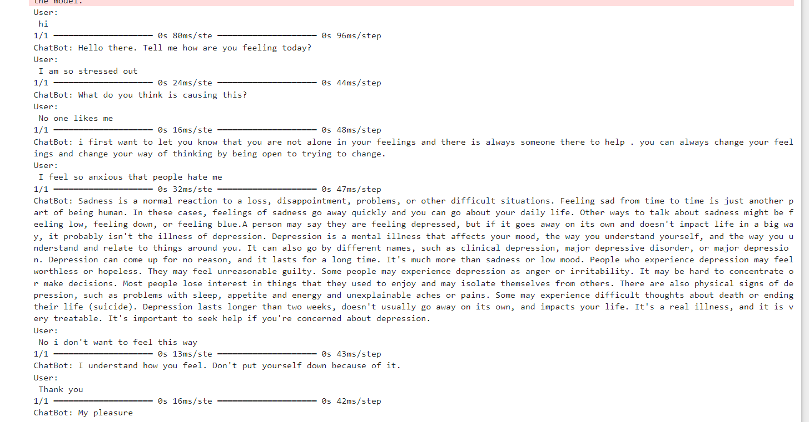

**Conclusion:**

In conclusion, the development of a chatbot powered by a deep learning sequential model represents a beacon of hope in addressing the multifaceted challenges surrounding accessibility and stigma within the realm of mental health support. Harnessing the transformative potential of cutting-edge technologies such as natural language processing and deep learning, we embark upon a journey towards democratizing mental health assistance, rendering it not only more accessible but also deeply personalized to the unique needs of each individual. As we embark on this evolutionary trajectory, continually refining and testing our chatbot, we envision a future where it emerges as an indispensable ally in the quest to fortify mental well-being and resilience within our society. Through concerted efforts and unwavering dedication, we aspire to catalyze a paradigm shift in mental health support, fostering a landscape characterized by inclusivity, empowerment, and holistic well-being.